Lesson 06 Demo 7
Create an S3 Bucket Using Terraform
Objective: To create a S3 bucket using Terraform

Pre-requisites: You need to have Terraform installed in order to proceed with this demo. If you don’t have it installed, refer to demo 1 of lesson 7.

Tools required: Terraform
Steps to be performed
- Set up Terraform components
- Create Terraform execution plan

Step 1: Set up Terraform components

1.1 Run the below commands in the given sequence to set up the Terraform component:

pip install awscli
sudo apt-get update

1.2 Create a new file to execute this project.

mkdir s3back
cd s3back

Step 2: Create a Terraform execution plan

2.1 Create creds.tf under s3back and add the code given below:

nano creds.tf

2.2 Paste the below code:

provider "aws" {
access_key = ""
secret_key = ""
token = ""
region = "us-east-1"
}
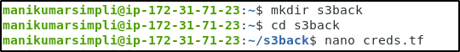

Note: Use the AWS access credentials provided in the AWS API Access tab in your LMS in your PRACTICE LAB tab as shown in the screenshot below:

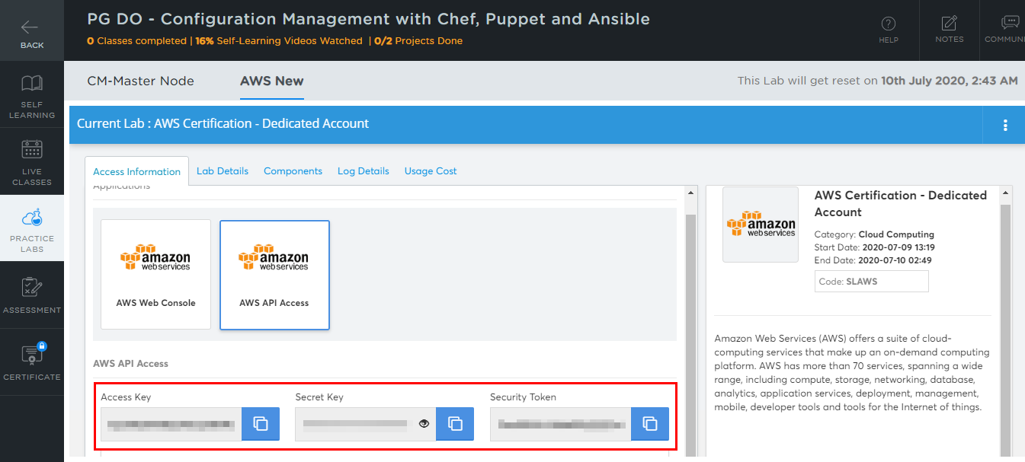

AWS access credentials will change when the AWS Lab session expires, every four hours.

2.3 Create main.tf under s3back and run the code given below:

nano main.tf

2.4 Paste the below code:
resource "aws_s3_bucket" "b" {
bucket = "my-tf-test-bucket"
acl = "private"

tags = {
Name = "My bucket"
Environment = "Dev"
}
}

Note: Bucket name (here my-tf-test-bucket) entered here should be unique globally otherwise it may throw an error while executing the script.

2.3 Run the below commands in the given sequence to add the AWS providers:
terraform init

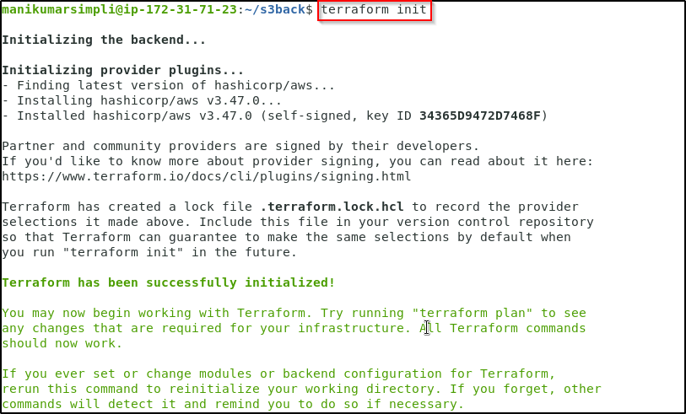

2.4 Run the command given below to commit TF state:

terraform plan

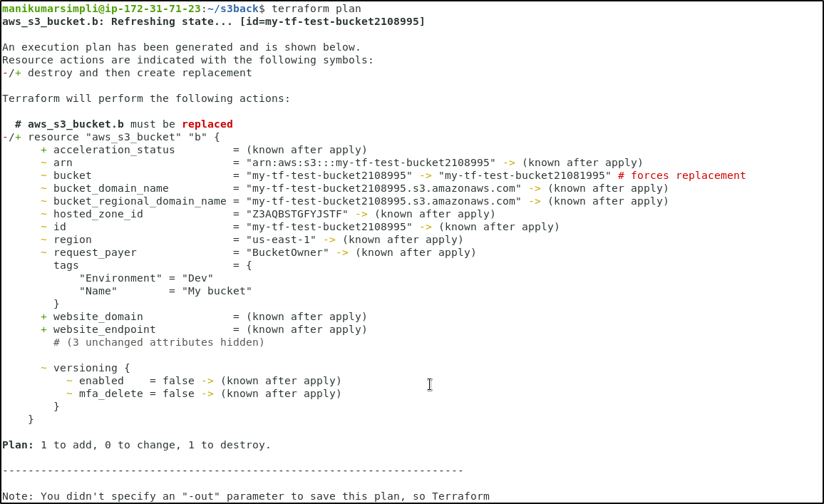

terraform apply
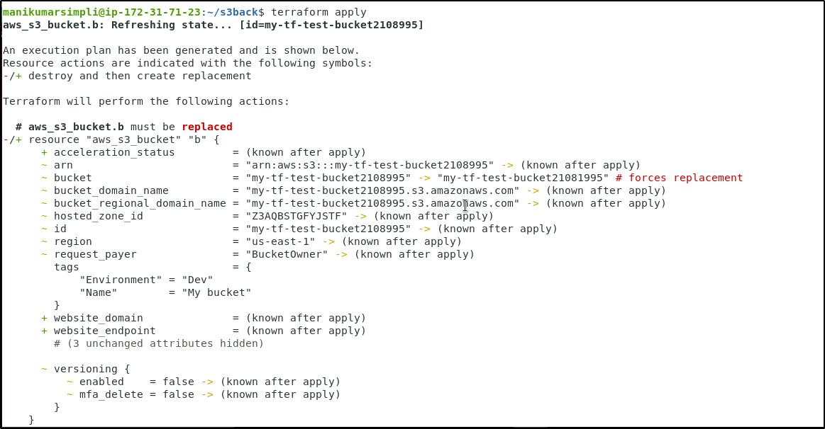

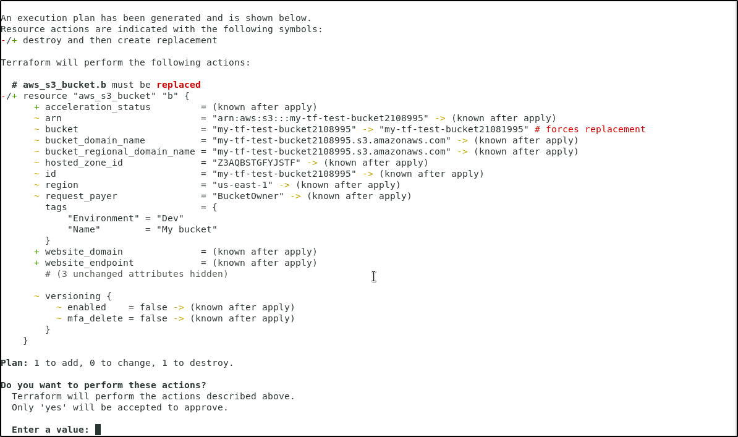

Enter a value: Yes
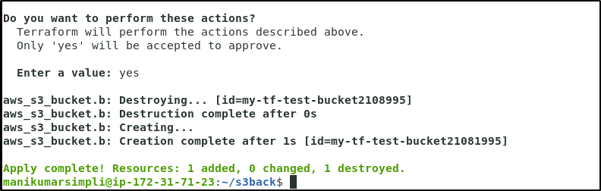

2.5 Verify the creation of S3 bucket in the AWS Management console

